Termite user guide for extracting FRIENDS Data:
Step 1: Download termite from this link https://www.compuphase.com/software_termite.htm and install it in your windows pc.
Step 2: Open the software.
Step 3: Set the appropriate com port and baud rate in setttings. Baud rate is fixed (115200) for FRIENDS device.
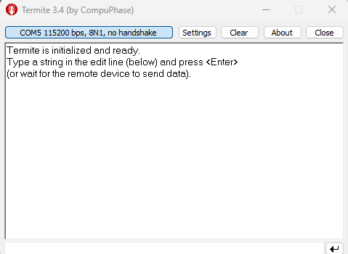
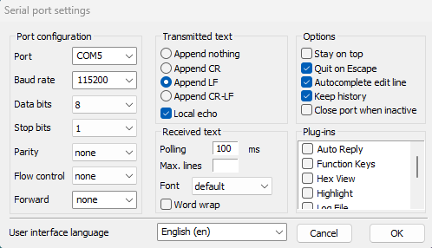

For accessing the appropriate comport-
- Connect the FRIENDS device via USB with your PC.
- Go to the device manager.
- Go to the Ports (COM) section to see the available USB serial port connection on the PC.
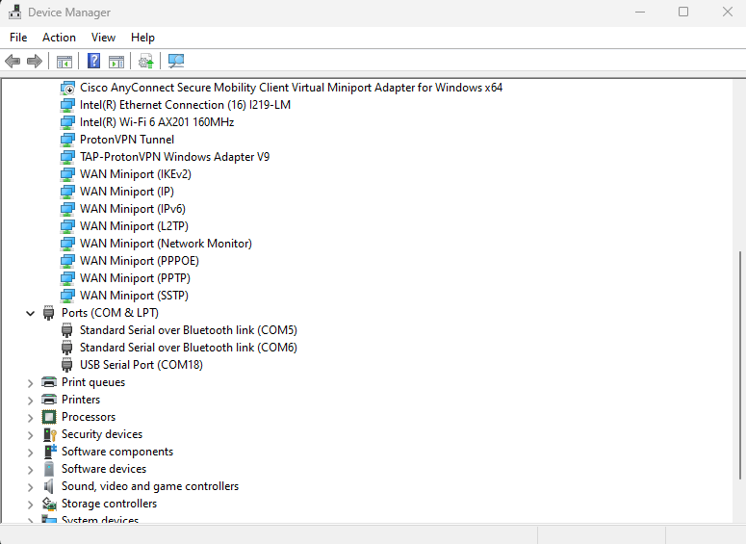
Step 4: Write “r” in the entry box (placed on the bottom part of the software) and send it to the device for getting the stored timestamps in the Flash.
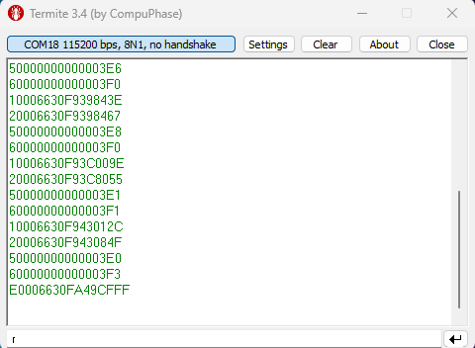
Step 5: Save the timestamps by pressing the right button on the RX monitor and selecting save option.
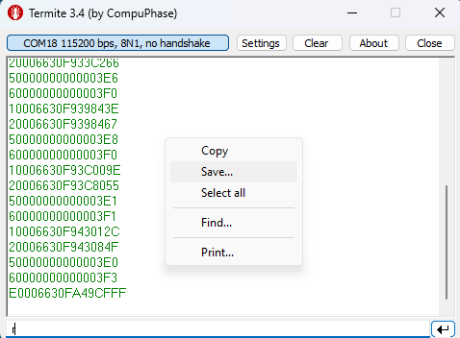

FRIENDS GUI user guide for extracting FRIENDS Data
open FRIENDS GUI> Select Appropriate Comport> Put Baud rate :115200> Press “Connect” button > Press “Read Data” button> Press “Save Data and Generate Plots” button.

FRIENDS GUI user guide for timestamp conversion and graph generation by using termite-extracted data.
Step 1: 1^{st,} you have to process the termite-generated file manually as shown below
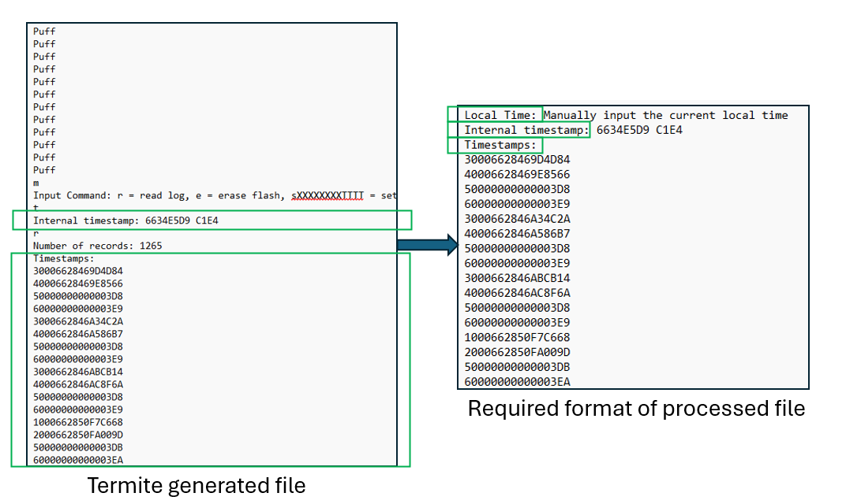
- Only consider the green-boxed information in the original file. Delete everything except the green-marked information.
- Manually add local time in the 1st line of the file (e.g., “Local Time: 2024-05-07 07:49:37” )
- Save the file.
Step 2: Open FRINDS GUI and utilize “File Conversion” button. The function of this button requires an input file with original timestamps and provides converted timestamps, extracted information, and associated graphs as output. You need to use the processed file from step 1 as input.

